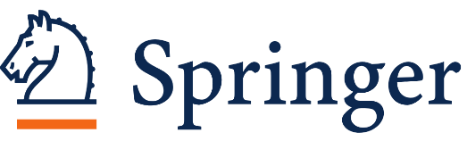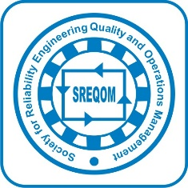

Dear Authors/Researchers,

1st International conference on Emerging Trends in Modelling and Optimization for Mathematical Sciences, Technology and Management (ICETMOMTM 2026)

(Theme: Data Driven Mathematical Methods for Engineering, Technology and Business Sustainability)

It is our pleasure to inform you that Department of Mathematics and Department of Statistics, AIAS, Amity University, Noida and Society for Reliability Engineering, Quality and Operations Management (SREQOM), India Regd., India are jointly holding the 1st International conference on Emerging Trends in Modelling and Optimization for Mathematical Sciences, Technology and Management (ICETMOMTM 2026) (Theme: Data Driven Mathematical Methods for Engineering, Technology and Business Sustainability) during October, 27-28, 2026 (Hybrid Mode) at the Amity Institute of Applied Sciences, Amity University, Noida, Uttar Pradesh, India. The focus of the conference is to address current topics of interest in area of Mathematical Sciences, Technology, and Business management. The conference will provide a common platform to foster research relations between the Universities and the industry. The topics of the conference are of wide range and important in current scenario.

We take this opportunity to invite you to submit a paper for the conference and present your research work.

CALL FOR PAPERS

Authors interested in presenting research papers of theoretical/applied nature are invited to submit an Abstract not exceeding 250 words latest by 30th September 2026 at etmomtm2026@amity.edu . The abstract should include all authors(Name, Affiliation, email), keywords/phrases, full address along with the broad conference topic.

The following topics of interest include, but are not limited to:

  - Mathematical modelling
  - Optimal control theory
  - Optimization
  - Interdisciplinary Research
  - Application in Business & Engineering
  - Modeling & Simulation
  - Multi Criteria Decision Making
  - Nature Inspired Optimization Algorithms
  - Mathematical modelling for Marketing of Social Innovations
  - Computation through Neural Networks
  - Bigdata Analytics
  - Software Quality
  - Software Reliability & Testing
  - Software Reliability Engineering
  - Total Quality Management
  - System and Network Security
  - Reliability Maintenance & Models
  - Artificial Intelligence and Machine Learning
  - Blockchain
  - Internet of things
  - Data and Intelligent System Modelling
  - System Performance through Computation
  - Vulnerability Modelling and Patching
  - Industrial Engineering
  - Inventory/ Material Management
  - Flexibility/Agility in Technology & Management
  - Sustainable Operation/ Logistics
  - Sustainable Supply Chain
  - Statistical modelling
  - Stochastic modelling
  - Risk
  - Probabilistic and non-probabilistic safety assessment
  - Biostatistics
  - Inferential statistics
  - Fuzzy sets and systems
  - Decision Sciences
  - Mathematical Biology
  - Special functions and fractional calculus
  - Mathematical Analysis

Publication Opportunity
After the conference, selected papers of ICETMOMTM 2026 after peer review process will be published in the Scopus indexed journal (as per that journal policies):
For more details and important dates, kindly go through the conference website:

Kindly encourage your colleagues and friends to participate in the conference as the theme of conference is very relevant and will also provide them an opportunity to interact with distinguished academicians and scientists from India as well as abroad.
For further queries, please write us on etmomtm2026@amity.edu or contact us on +91-9968047843

Looking forward to hearing from you.

Organising Committee, ICETMOMTM 2026

