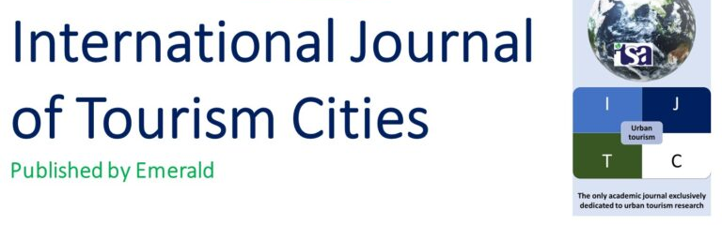

SPONSORSHIP INVITATION FORM
For
ITSA- AMITY REGIONAL CONFERENCE FOR ASIA
ON
“Bridging the Gaps in Tourism Knowledge and Practice: Sustainable Development, Regenerative Tourism , Digital Eco-Systems and Green Investments”
7th-9th February 2025
Name of the Organization _________________________________________________________________________
Name of the Contact Person _______________________________________________________________________
Address_______________________________________________________________________________________
City______________________________________State _______________Cell no. __________________________
Telephone _____________________________________Fax_____________________________________________

Sponsorship Details:
- Platinum Trade Partner---------- 2,00,000 & above
Benefits – 15 minutes presentation as special speaker , prominent display in printouts/logo and punch line on the top corner of the inaugural & valedictory backdrop special mention during the inaugural & valedictory session of the event, Small Promotion Display at the Venue of event.

- Gold Trade Partner---------- Between 1,00,000 – 2,00,000
Benefits - Name in printouts/logo and punch line on the inaugural backdrop /mention during event/souvenir/ photo and media opportunities.
- Silver Trade Partner ------------- 1,00,000
Benefits - Logo in printouts and the side panel of the valedictory backdrop / photo and media opportunities & special mention at event during plenary sessions.

- Conference Support Partners ----------Between 50,000 – 1,00,000

Promotion through logo on the backdrop mention during the events wherever applicable.

Sponsor may be listed as: _________________________________________________
(Please email logo if applicable to aitt@amity.edu clearly indicating SPONSOR in subject matter)
_______________________________________________________________________________________________
Supported By :- Official PCO:-

Please make draft / check payable to " Amity University Uttar Pradesh" payable at Noida/ Delhi
Details of the Payment:
Draft Number/ UTR No.: _______________________Amount:___________________Date: _____________________
Drawee Bank_________________________ Branch________________________Signature: _________________

