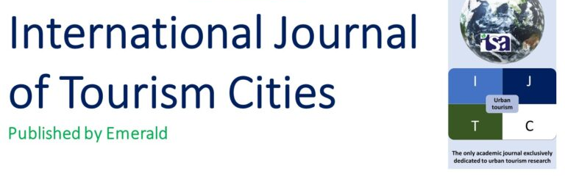

SPONSORSHIP INVITATION FORM
For
ITSA- AMITY REGIONAL CONFERENCE FOR ASIA
ON
“Bridging the Gaps in Tourism Knowledge and Practice: Sustainable Development, Regenerative Tourism , Digital Eco-Systems and Green Investments”
7th-9th February 2025
Name of the Organization _________________________________________________________________________
Name of the Contact Person _______________________________________________________________________
Address_______________________________________________________________________________________
City______________________________________State _______________Cell no. __________________________
Telephone _____________________________________Fax_____________________________________________

Sponsorship Details:

- Destination Partner ----------Between 50,000 + GST 18% (Applicable for State/International Tourism Board)
- Deliverables:-

- Display Stall area (6 x6 ) for 02 days of conference (07th & 08th Feb 2025).
- Branding through logo display on backdrop and all other promotional material during the event & also through post event releases.
- Promotional advantages as "Conference Support Partners" through International and National aggressive promotional campaigns.
- Destination promotion through short film/ promotional advertisement in the morning of each day of the conference ( Total duration available will be 2-5 minutes for each Tourism Board).

Sponsor may be listed as: _________________________________________________
(Please email logo if applicable to aitt@amity.edu clearly indicating SPONSOR in subject matter)
_________________________________________________________________________________________________
Supported By :- Official PCO:-

Please make draft / check payable to " Amity University Uttar Pradesh" payable at Noida/ Delhi
Details of the Payment:
Draft Number/ UTR No.: _______________________Amount:___________________Date: _____________________
Drawee Bank_________________________ Branch________________________Signature: _________________

