CONFLUENCE 2011 – Amity University in association with EMC
Theme: Information Storage, Security & Compliance for Business Excellence
On January 27-28, 2011 at Amity University Campus, Sec- 125, Noida

Amity School of Engineering and Technology (India’s top ranked Engineering school) in association with EMC added another feather to its cap by organizing – CONFLUENCE 2011-The next generation IT summit. The summit focuses on Information storage, security and compliance for business excellence.

IT refers to acquiring, processing, storing and disseminating information based on a combination of computing and telecommunications. As the world gets digitized the problems associated with information management and security increases.
The main idea of the confluence is to bring together the accomplished leaders and consultants of IT industry, the research scientists and the immature academicians and students at a common platform.

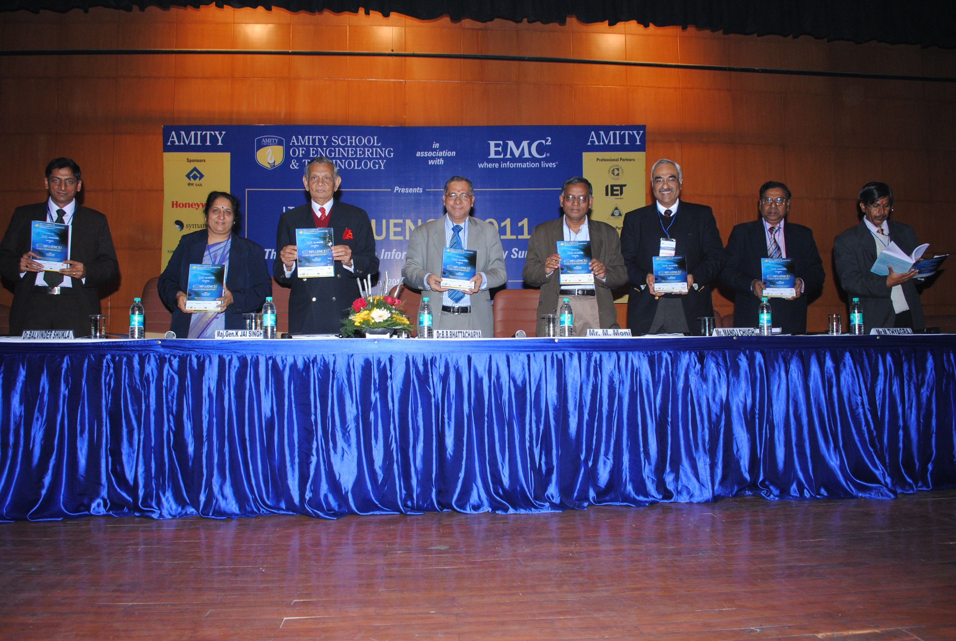
Proceeding Release during inaugural ceremony of Confluence 2011

The entire event was partitioned into 3 sessions which included 4 tracks based on the 4 core areas that this summit sheds light on. Session 1 and 3 were focused on the 4 tracks where as the Session 2 focused on sectoral case studies. The sectoral case study involved some of the most influential, and the most vital industries such as Telecom, Banking, Aviation, Government, Healthcare, Tourism, Education, Research, Automobiles and Media.
The 4 tracks are as follows:

TRACK | DESCRIPTION | KEY FEATURES
Cloud computing and its Impact | Location independent computing. It involves delivering- “sold on demand” ,”elastic” and “managed”- hosted services over the internet. | - Green Data Centers  - Intelligent Information Infrastructure  - Cloud Computing  - Data Optimization  - Collaboration  - Impact - application
Business Intelligence, Analytics and Enterprise Performance Management | Business Intelligence and analytics are the main tools to guide business decisions, develop strategies and create innovative ways of doing business. | - Data mining and business analysis  - Content management  - Information and Knowledge management  - Information & CRM
Information Security and Management | Deals with the security and management of the most critical aspect of any organization- Information. It involves one of the prime concerns of any industry- “ the security of its data” | - Information Asset Management  - Network Security and Cryptography  - Security Protocol  - Security Policies and Strategies.
Web Security and Compliance | It aims to delve deeper into issues like Cyber threat and security norms and laws with software security, risk management and rights management as the key area of discussion. | - Cyber Threats & Security  - Security Norms, Laws & Compliance  - Software security and Risk Management  - Digital Rights Management

DAY-1

The event went on track with the blessings of the Almighty- the Light Lamping Ceremony.

ASET Director General Dr. Balvinder Shukla inaugurated the summit by her valuable words on IT and the importance on the protection and security of information. This was followed by a keynote speech by President of EMC (India and SAARC) Mr. Manoj Chugh on the significant changes in IT industry, the importance of ever expanding IT industry and factors that trigger it, and on the “F-generation- the Facebook generation” of IT.Guest of Honor Dr. M. Moni emphasized on the development of technology and algorithms for the growth of “F-generation” and on information as the basic building block of IT industry.

Econometrician Dr. B.B. Bhattacharya Vice Chancellor of Jawaharlal Nehru University accentuated on the importance of IT in day-to-day life by quoting examples from his own experiences and importance. He also stated the significance of software industry in India and the future challenges that she faces in this particular industry.
Major General K. Jai Singh Vice Chancellor Amity University Uttar Pradesh shared his lifetime achievements and experiences in communication and technology. He stressed on the significance of two C’s – communication & computers and their relation to IT.
Retired CIO, ONGC Mr. M. Thyagaraj shared his thoughts on using IT as a leverage to business excellence and on the prominence of meaningful information.
Professor Ajoy Kr. Ray shed light on data mining and the various dimensions of data. He focused on data analysis, data compression, data security and the interrelation among various fields of IT.

Notification of Call for papers was issued at the time of announcement of the Conference. Overwhelming response was received in terms of paper contribution by the researchers from academia and research centers from all across the country covering 14 States North, East, West, and South India giving a flavor of National level in the true sense. In all total 110 papers were received in response to Call for Papers covering Andhra Pradesh, Karnataka, Tamilnadu, Kerla, Tripura, Maharashtra, Delhi, Uttar Pradesh, Rajasthan, Haryana, Madhya Pradesh, Punjab, Goa and West Bengal. These papers were reviewed by a review committee and based on their recommendations 36 papers were included in the proceedings published for the conference. The proceeding was released by the Chief Guest of the conference in the inaugural session and the dignitaries present on the dais.

Prof.(Dr.) Abhay Bansal, Head of Department ASET(IT Department) appreciated the efforts involved in organizing the event.

PLENARY SESSION-1-Challenges and future ahead.

Mr. Manoj Chugh President of EMC (India and SAARC)-Session Chairperson inaugurated the session by introducing the invited panelists. He shared his opinions on cloud computing. He stated that cloud computing takes IT to a new level by implanting new passion in the industry. He introduced the topic of discussion “Cloud Computing and its impact”.
Cdr. Anil Saxena, director IT Governance and PMO, Mobile Tally systems, explained the general concept of cloud computing. He gave a presentation on the same to make the concept crystal clear.
Mr. Manoj Chugh cleared certain terms related cloud computing.
Mr. Pradeep Aggarwal talked about the latest trends in IT. He shared the vision of Google on cloud computing. He discussed the advantages of cloud computing.
Mr. Amit Nath, Country Manager- Trend Micro focused his speech on the security of cloud which is the prime concern in cloud computing. He explained the key reasons for the need of security in cloud.
Mr. Neel Aggarwal- Manager Sales discussed the out shores of cloud computing.
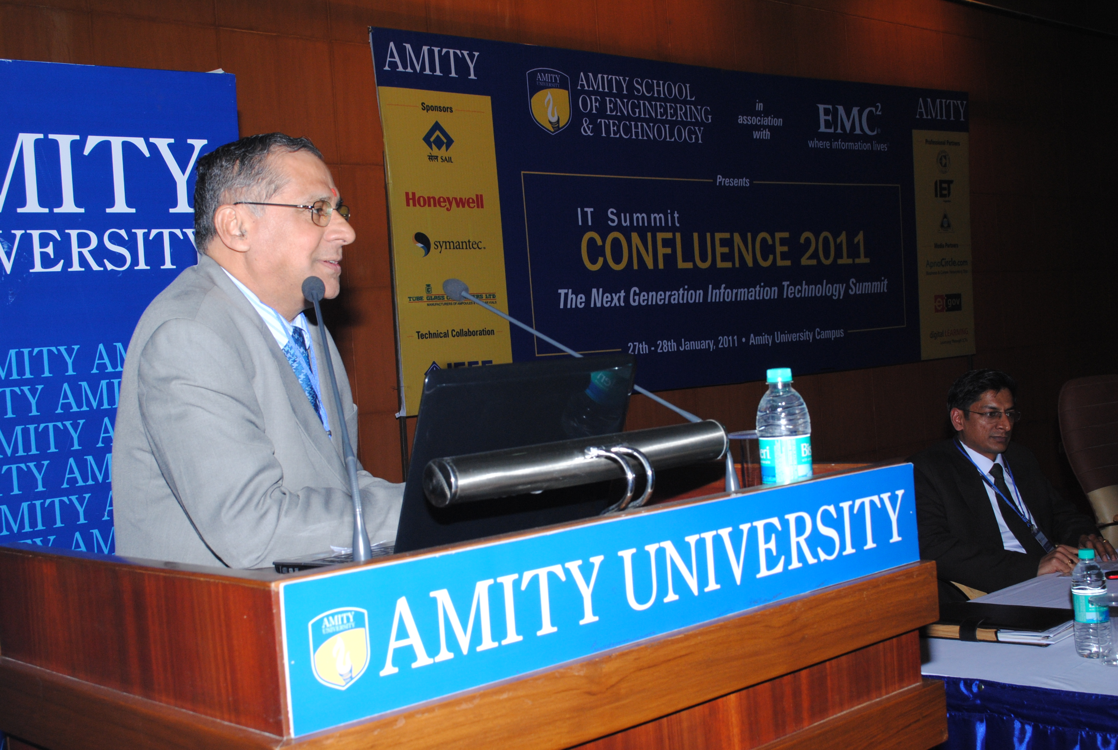

TRACK 1- Cloud Computing and Its Impacts

Honorable chairperson Dr. B. K. Murthy, Director, NKND, Ministry, Ministry of C & IT, Department of IT, Government of India, welcomed the lead speakers with saplings and gave an intriguing session on cloud computing and its impact.
Mr Chetan Aggarwal, Group CIO, Jindal steel and Power ltd. Commenced the session by defining cloud computing, cluster computing and cloud as a model like CRM.
Mr Shuja Mirza, Advisory Tech Consultant, Virtual Computing Environment, enhanced the knowledge on the wide network and its maintenance which is fairly difficult. He also emphasized on the need of cost reduction and efficiency improvement. He said cloud computing treats IT as a service and not as a part of IT itself.

Mr. Vinay Dua Manager CISCO started on the note of “Go Green” quoting that Green id the color of money as well. He also said that the changing phase of IT makes the use of cloud so important.

Mr Puneet Nath Kapil, Senior Manager CSC, Said that cloud computing not only ensures scale up and speed up but also ensures reliability of information and timeliness.

TRACK 2 - Business Intelligence – Information and CRM
Professor S.K. Gupta, The session Chairperson, introduced the concept of Business Intelligence and Enterprise Performance Management.

Mr. Pradeep Kamalanabhan, Technical Consultant, EMC Information Intelligence Group resolved the following issues – what challenges do enterprises face, what are the typical end to end solutions, what intelligence needs to be added to the enterprise and how enterprise content management works for many organizations. He emphasized on innovation stating the organizations need to be dynamic in their approach to processes. He informed the audience about the critical tools and Information Intelligence Group Strategy.

Mr. Shobit Mathur, Sales Advisor, Cordys Asia focused on the business intelligence related to CRM- it is all about the customer. He defined Business Intelligence as something that captures data or transforms mission critical data. He explored CRM and its levels. He also touched the topic of evolving role of Business Intelligence.

Mr. Ravi Kothari, Associate Director, IBM Research Lab, gave an overall view on Business Intelligence and Data Management. He talked about managing data efficiently using the concepts of business intelligence. He compared the classical approach with the modern approach of business intelligence.

Mr Anuj Gajanan Ghanekar, General Manager, CSC, shared his views on fact based decision making. He explained the “PDCA- Plan- Do – Check- Act” model. He laid importance on Continuous Improvement to Ensure Success.

POSTER PRESENTATION

A poster presentation was held on the following themes Business Intelligence, Information Security and Security.
Under Business Intelligence, two posters were selected for the finals” CRM in Social Network”- Abha Lakha- it is about combining CRM with social networking for customer satisfaction, “Extreme Programming”- by Ankur, Abhishek and Deepika- based on software development life cycle. It is an agile methodology which is flexible and light weight.

Under Information security 3 posters were selected “Encryption-Decryption and Cryptography”- by Kulveer Singh, Karuna Puri and Ishaan Vats, “Information Security and Management”- by Ankita – how to maintain server side security over a network, retrieving and recovery of data from Server in case of failure, “ Art of deception” – By Sameer, Megha, G.Satyanarayan based on social engineering.

Under Web Security 2 posters were selected – “ Digital Water Marking” –by Divya Raje Singh,Anil Yendremban and Harshit singh- based on inserting an audio/video information in an image, “Cyber Threats”- by Prakash Pradhan, Pramood Kumar and Rohit Goyal- based on Phishing spams.

DAY-2

The second day of the confluence began with fervor and zeal.
Session Chairperson Dr. J.S. Sodhi, Assistant Vice President, AKC Data Systems inaugurated the 2nd plenary session and introduced the speakers. The session was on the theme –“Information Security, Compliance and Business Trends- Technological challenges and strategies”. He explained that the session would focus on the following points – “what is the role of technology”, “requirement of training” and “attitude of users on security.

Mr. Pradeep Saluja, Principal SE Asia Specialist and consultant, Symantec gave the presentation on the theme of “New frontiers in security”. He said that information protection was important earlier but as the semantics has changed everyone wants to make solutions more specific. He touched topics such as “landscape threats” and “web based threats”, “malware” and “web 2.0 Threat- Phishing Bait, Trojans, Botnets and social networking worms”.

Mr. Avinash, Network Administrator- ONGC, discussed about the internet and the security mechanisms that are required. He gave the presentation on the following themes Internet; need to protect data and resources, types of attacks- denial of service, social engineering and virus, security mechanism and objective. He outlined the main security objective – identification, Authentication, Access control, data Integrity and Confidentiality.

Professor Navin Rajpal, Guru Gobind Singh University,gave an interesting session on steganography – its technique and history.

TRACK -3 & 4

Dr. Daya, HOD(CSE)- Delhi University, spoke regarding “internet security & legal compliance regulating cyberspace, convergence & standardization of technology. She briefly described “laws and legal services related to internet.

Mr. Shantanu Sinha Director Academics, Institute of company secretaries of India (ICSI) spoke on the need for data security, computerized MIS and networked environment. He explained Cyber terrorism. He even explored the topic of Decision Support systems based on MIS. Topics such as economics of Data Security, KPO, LPO, E-commerce and E-governance were also covered.

Mr. Himanshu Tiwari, President of Cybersuraksha, discussed the changing attack scheme networks, buffer and security standards.

Mr. Prasanjit Bose, Senior Manager, IT Infrastructure, Microsoft, gave an insight on Microsoft Enviornment and Data Protection in that environment.

PLENARY SESSION 3

Mr. Venkatraman stressed on the point that the industry should work together with the educational institutions so that the students understand how an industry functions.

Mr. Huzoor explained the importance of models and tools for future studies. The education system should be focused on the next 50-60 years. He laid importance on the point that case studies should be incorporated in the system and the industry should take initiative for this.

Mr. Sandeep Parikh, Microsoft India, said that the narrow gap between Industry and Academics should be bridged. He emphasized on the following points -both- Theory and Practicality need to be incorporated in the educational system,Insititutions should provide skills, students should be open minded and students and the faculty both need to improve their skills.

Mr. Tusshar gave an insight on what is IET doing for bridging the gap between Academics and Industry. He explained the need for discussion forums to discuss the basic problems and new ideas.

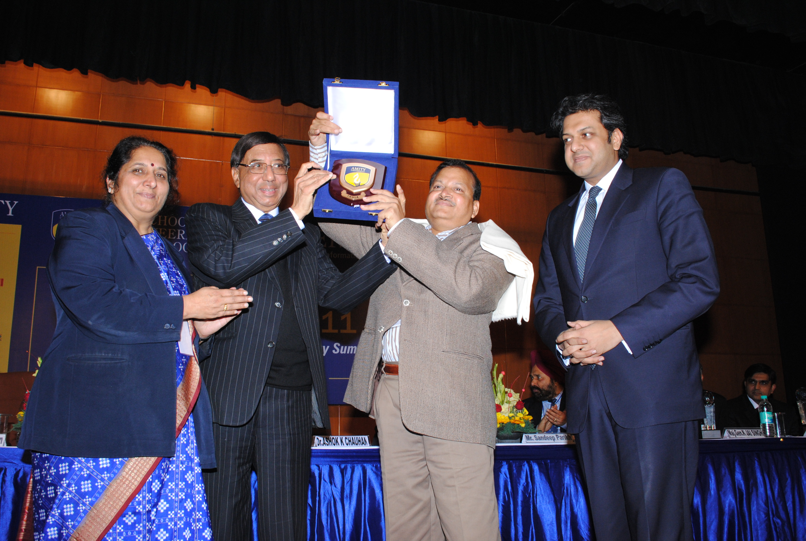
Hounrable founder President Dr. Ashoke K. Chouhan along with Dr. Balvinder Shukla, Pro VC(A), and Mr. Aseem Chouhan, VC, AUR, presenting momento to Guest of Honour Sh. Shankar Aggarwal, Jt. Secretary, Dept. of IT, Govt. of India

The day ended with the valedictory function in which the accomplished people of the industry were awarded by Guest of Honour Sh. Shankar Aggarwal, Jt. Secretary, Dept. of IT, Govt. of India , Dr Ashok K Chauhan, Founder President, Amity Education Foundation and Chairman AKC Group of Companies, Mr. Aseem Chauhan, Additional President & Chancellor AUR and Dr. Balvinder Shukla, Pro Vice Chancellor (A) & Director General ASET and Chairperson, Conflence-2011

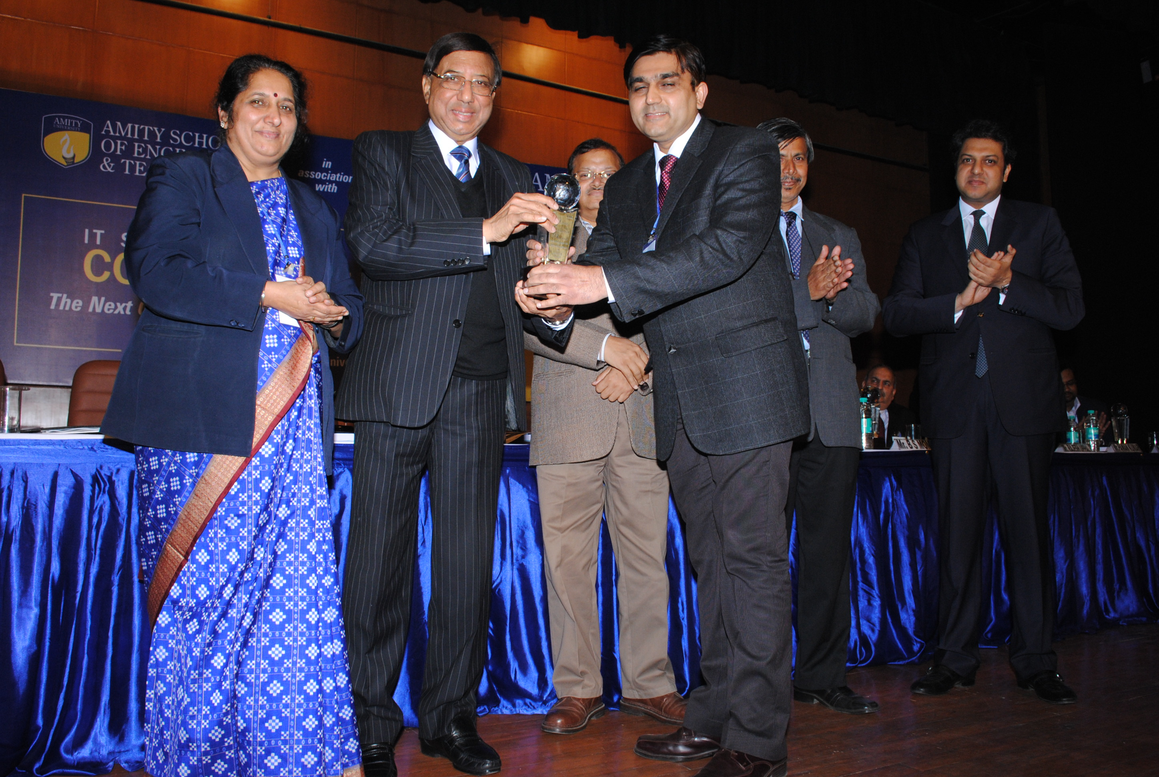
Mr. Rajesh Uppal CIO, Maruti Suzuki Ltd. Receives Amity Leadership Award from hounarable Founder President Dr. Ashoke K. Chouhan

. The following well known faces of the industry were awarded –
Mr. Ravinder Jain – CIO, Telecom Sector, Aircel India
Mr. Rajesh Uppal- Exec. Officer, IT and CIO, Maruti Suzuki Ltd.
Mr. B.S. Momi – Chief Information Security Officer, ONGC
Dr. R.S. Oberoi – Chief quality officer, Appolo Hospital Groups
Mr. Abhishek Jain- Senior Development Manager, Samsung India
Ms. Ragini Chopra- Vice President, Corporate Communications and Public Relations. Jet Airways.
Mr Sandeep Parikh- CIO, Microsoft Co.
Mr Pawan Kumar- Head HR, India Today Group.

Conference Dinner were also organized on 28th Jan, 2011 for networking and same was attended by Sr. Professional from Corporate and Academia.

For Confluence 2011 Professional Partner were Computer Society of India(Ghaziabad Chapter),IET(UK)(Delhi Chapter), IETE and Technical Collaboration with IEEE(Delhi Chapter).

For Confluence 2011 sponsors were EMC Corporation, SAIL, Honeywell, Symentic, Tube Glass Containers Ltd.

It was a journey through some of the most important challenges faced by the current IT industry. It provided a sneak peek at the emerging technologies and their impact on business. It is an opportunity for the researchers to share and display their work with the major sector of IT industry. It aims to provide the audience a detailed perspective of the security challenges and the key management issues related to the current IT scenario.
The success of confluence 2011 and the theme of the confluence 2011-Information storage, security and compliance for business excellence signify the importance of this event for the IT industry professionals, research scientists and scholars, and the students who want a career in IT industry. It was not only a great learning experience but also a merger of various ideas, innovative thoughts and resolutions for the next generation of the IT industry.

